KEEP ON ‘COURTING’ YOUR WIFE!

Introduction
After you have been married for a few years, it is easy for life to get mundane. Everything becomes routine, and everyone is caught up in their own busyness. Romance is gone. Maybe you hardly even notice what your wife is wearing. Think back to what it was like when you first fell in love with her. How did you treat her then? How can you show that same love to her now, but even more deeply? We find a good summary in EPHESIANS 5:25; 28 “Husbands, love your wives, even as Christ also loved the church, and gave himself for it. So ought men to love their wives as their own bodies. He that loves his wife loves himself.”

A ROSE NEEDS LOVE
A Rose without water will wither.
A Rose without sunlight will fade.
And the Rose without love and attention
Will not live even one day.

So don’t take the love that is given
And crush it and throw it away.
For words that are spoken harshly
Will cause love to die all the way.

So speak softly to your darling
With tenderness and care,
Then the Rose that you so wanted will bloom to its fullest,
And will grow deeper for you each day.

For in giving your best to your loved ones,
And caring for what they have to say,
You’re saying, “Darling, I love you,”
In one of the most precious ways.

Jesus said, “love one another,”
And without this love we will die,
So water your Rose carefully,
And plant it deep in the love of God’s ways.

--A. Fiasconaro

I. REMEMBER HER NEEDS:

A. She has a need to be LOVED
Remember her need to be loved. The scriptures command husbands to love. How unusual. Husbands are somewhat brutish, have a lack of tenderness and love does not come as natural. A man maybe has a need for sex, but a woman has a need for love. Wives need love, they thrive on it. It is part of their nature; they are very generous with it and need to have that love reciprocated by their husband. For a woman to be loved takes time. This is the biggest complaint women have about their husbands. “He gives me very little of his time.” Therefore, they think that you do not love them very much. Guard your first love and express it.

B. She has a need to be NEEDED
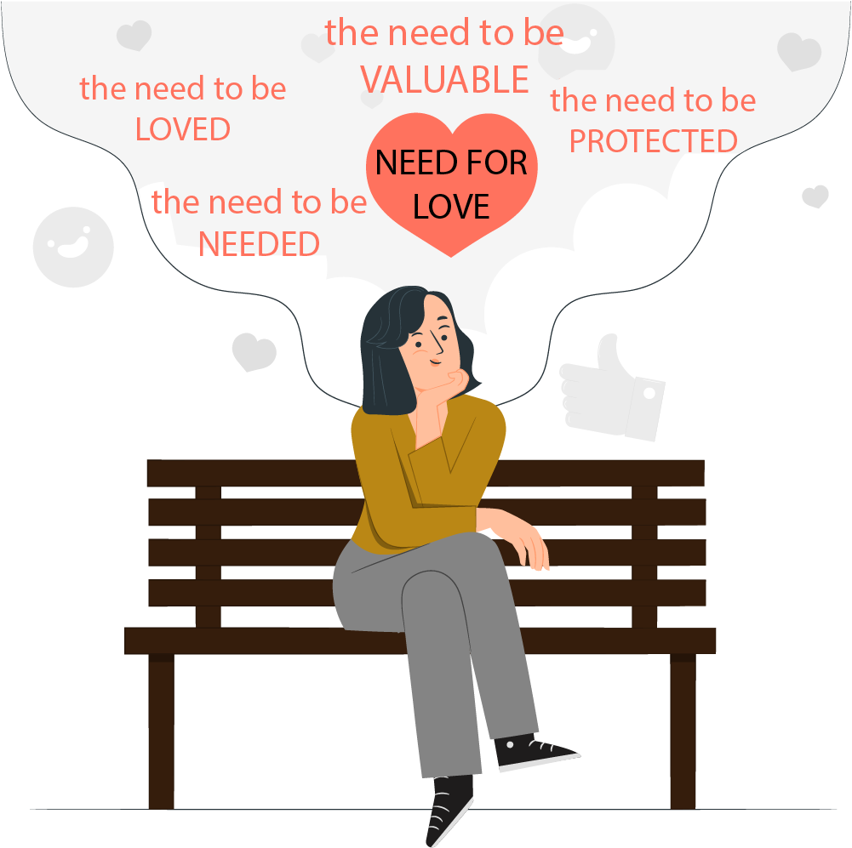
Remember her need to be needed. A woman is God’s helper to you. Wives are created to be helpmates and they have an innate need to assist and to serve. And this is how she feels about it. If you tell her, “Oh, it’s nothing. I’ll do it myself.” Or, “It’s not important, somebody else can do it.” She will be offended. You can ask some of these ladies if they agree. A woman likes to hear, “Can you help me, sweetheart?” A woman likes to hear, “Thank you for making my clothes nice and clean for the conference.” A wife’s hands are always busy doing something. Don’t be too self-sufficient. Allow her to assist you. Let her help you and provide opportunities for her to please you.

C. She has a need to be APPRECIATED
Remember her need to be appreciated. Be appreciative and express it to her. Notice her service with ‘thank yous.’ There are myriads of things she does constantly. Think of your emptiness and need if she was not there. I do not need to be appreciated all the time. If somebody once a month tells me I am OK, I am happy. My wife likes to hear it every day. Don’t be bashful. Don’t begin to take things for granted. Appreciation expresses the value she has to you.

D. She has a need for ________________________
1. She needs security in your attitude — Yours should be an attitude of, “I am happy with you. I am proud of you. I trust you.” And so on. Is your attitude constant or does she have to “read your barometer”? Are you a one-woman man mentally? Does she have that total security?
2. She needs security in your affection — Is your affection steady or does it depend on your mood swings? She needs your affection. Almost all women have a desperate need to be hugged once a day.
3. She needs security in your finances — Is God using you to supply the needs for your family, or is she left to fend for herself? She should not have to worry about money!
4. She needs security in your leadership — The number one Biblical requirement of a spiritual leader is to lead, nurture, take care of and provide for his family. She should know that you will take care of her and the children. She has a need for security. Are all family angles covered?

II. REMEMBER THE BIBLICAL INJUNCTION
“Love Your Wife As You Love Yourself’
This is what Jesus does for the church. He wants to do that with each one of us. And, it is His desire that you men should do this with your wives. In the same way! You should love your wife as your own body. We love our bodies very much indeed. The evidence is very concrete: we love ourselves more than anybody else. Our relationship with our wives is a mysterious relationship. The relationship of Jesus with His church is a mysterious relationship. But — just as we have that relationship with Christ and He with us, in the same way we should have that relationship and priority with our wives. The final command is,
“However, each one of you must love his wife as he loves himself.” (Eph 5:33)
and,
“Husbands, in the same way be considerate as you live with your wives, and treat them with respect as the weaker partner and as heirs with you of the gracious gift of life, so that nothing will hinder your prayers.” (1 Peter 3:7)
It says here that you should be considerate of your wives. A good prayer life depends on how you treat your wife. There are some of you who could have a much better spiritual ministry than what you now have. It all depends on how you _______________ your wife. If you learn to treat your wife better, everybody will see it. And out of that will come a very strong testimony. God will begin to bless you more and more and more. Your children will become spiritual children who love the Lord Jesus and will want to do spiritual work also.

III. REMEMBER ALL HER love NEEDS:

A. She has a need for Emotional Love
She thinks very differently from a man. She is looking for a husband who will understand how she feels. Many times a woman will burst out crying. Especially when they are younger women.
My wife was crying once. And so I said, “Honey, what is the matter?” I said, “Why are you crying?” “Eeeesidoeabwefhyou! I do not know!” She was crying but she did not know why she was crying. And I could do one of two things. I could say, “Now, that’s stupid!” Or I could get my handkerchief out and say, “That’s OK.” Sometimes crying just helps people to relax. And when I did that, within half an hour, she was laughing. And the whole day she was singing. And in the evening I got a hug. She said, “You are the best husband!” I didn’t do anything. I just let her sit and cry for a while. Without criticizing. Ladies have that need.

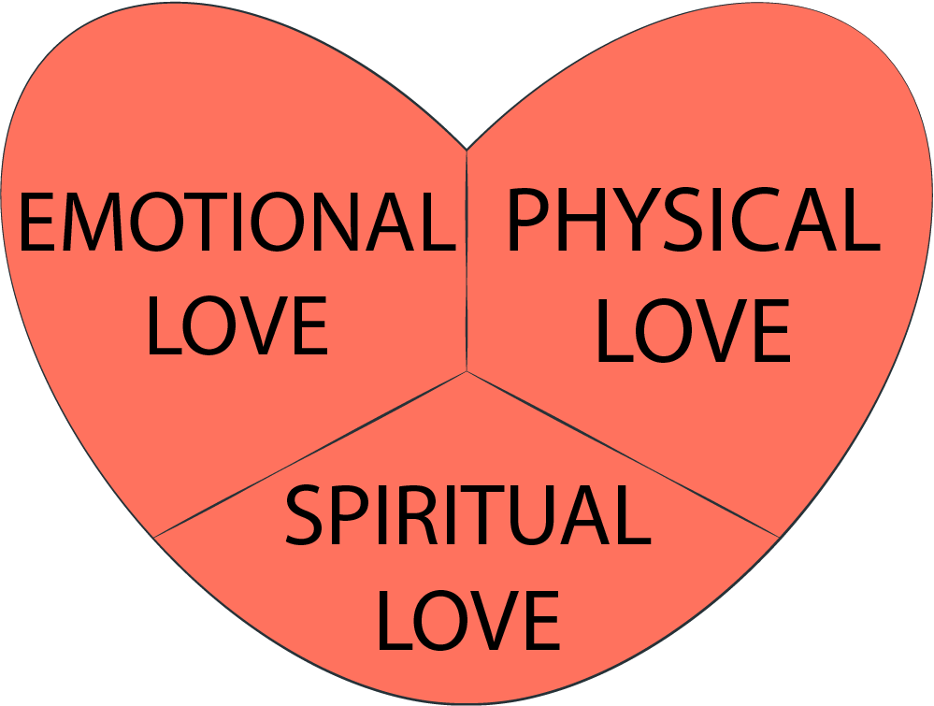
B. She has a need for Physical Love
Women need to be touched. They need to be caressed. They need to be kissed. Sex in itself is not sufficient for a woman. It takes a long time for a woman’s body to respond to the sexual needs of a man. Physically a man’s body responds almost instantaneously and a woman’s body requires a slow long warm-up time to be ready for marital intercourse. This difference in bodily time clocks is one of the biggest problems in an unhappy marriage. If you truly want to have a Holy Matrimony than please take time to prepare your wife’s body to relax and feel like she is loved, prior to having sex. Remember in God’s sight Holy Matrimony is a sacred thing.

C. She has a need for ___________________________ Love
That is why I talked about having a Bible study with your wife. She has a real need for something like that. Maybe one hour a week or so. She needs a husband who talks about spiritual principles with his family. Dear husband she wants her precious man — that is YOU — to set the example and lead her and the family closer to God. Your best example is Joseph the fiancé of Mary. Think about all the humility, the sacrifice, the care, the patience and endurance he exhibited for this pregnant girl and the baby that wasn’t his. He really showed spiritual love so that by age 12 the Pharisees were already shocked by his stepson’s spirituality.

IV. REMEMBER THAT LOVE IS giving
So before you go home , you had better get flowers from somewhere. And you need to give something to your wife constantly. Maybe you found some cookies, or maybe just a flower or maybe something else. It doesn’t matter what it is. You know what the real issue is? You come home, and you say, “Honey, this is for you.” And she knows “He was thinking about me today.” That is the issue for her. Were you thinking about her? To love is to give. There is no other way to express love except by giving. Love is an action verb and it requires not just talk but a physical act of presenting something to a loved one. Love is giving a gift. The most important thing that you can give to your wife is time.

V. CONSIDER THE PROBLEMS OF GIVING LOVE:

A. Getting so BUSY
Life is busy, and it will always be busy. Men quickly get caught up in this because seeing goals accomplished is so rewarding. But there are some goals that are not so obvious. One of these is courting your wife and making her feel special. If you are too busy to do that, you are too busy. Schedule time with your wife! That’s right. Write it down on the calendar.

B. Forgetting her NEEDS
Along with that busyness comes a lack of focus on your wife and who she is. Before you were married you asked her what was wrong, what she wanted, what she needed. Stand back and take a good look at your wife and her needs. What are her specific needs right now? We’ve already talked about these in general, but what can you do to meet these in specific ways? It is surprising what a little gesture like washing the dishes will do for her

C. Getting out of SHAPE
Do you take pride in who you are? Maybe you are too “spiritual” to think about what shape you are in. It is easy to pick up a few pounds here and there, and next year a few more. You are so busy doing spiritual things you don’t even work in the garden anymore. What does that mean? More pounds, less strength! Maybe you need to change that, and do it for her! Not for your pride, but to honor your wife.

D. Being too TIRED
“I know we haven’t had any time to talk today, but I’m just too tired. I’m going to bed.” How many nights a week does that happen? Always tired, and what gets the lowest priority? The things other people don’t see. That intimate relationship with your wife, with your family. Get more rest. You don’t have time? Then make sure the time you give to your wife is not at the end of the day when you fall asleep while she is talking. And re-examine your lifestyle to see why you are chronically tired.

E. Being THOUGHTLESS
“Oh, that’s right. You asked me to pick up some sugar, but I forgot.” I forgot, I forgot. Why did you forget? The only reason in her eyes is that she wasn’t important enough to you. You communicate the same message when you don’t help her on with her coat, but you carefully help another woman to put hers on. If you do that kind of thing enough times, she will get the message. “No, I don’t really count in my husband’s life. He doesn’t really care.” And nothing you say will convince her of anything else as long as you are thoughtless in what you do.

F. Focusing on her ______________________________
Tell me what bothers you about your wife. “Well, she doesn’t cook like my mother. She’s too bossy. She nags me all the time. She talks on the phone too much.” Okay, now tell me about her strengths. “Uh, let me see. Well…..” It is so easy to focus on the negative. If all you see are her weaknesses, you will tear her down instead of building her up. What does your wife do well? When did you last compliment her?

G. Revealing her WEAKNESSES to others
“Oh boy, you won’t believe the stupid thing my wife did last week!” Would you want her to hear you say that to someone else? Put yourself in her shoes. Do you want her telling everyone about your weakness, how you lose your temper over insignificant things? That you haven’t fixed the drain in the sink for a year and she has to keep emptying the bowl from underneath it? No, of course not! Don’t ever downgrade your wife to others, whether she is there or not.

VI. Neglecting built-in opportunities
Maybe you think, well, I don’t have more time to spend with her. How am I ever going to fill her needs? I have my own needs you know! Here are a few opportunities that you can take advantage of.

A. At the beginning and ending of the DAY
First thing in the morning when you get out of bed, tell your wife you love her, ask her how she slept. Give her a few minutes of extra attention. When you go to bed, tell her you love her. Tell her she is beautiful. Praise her about something. Always think of something different to say.

B. At MEAL times. (Be on time)
And during the meal, look at her; ask her how her day was, or what she is planning to do that day. Ask her a creative question, “What is your favorite song now?” “What would you do if you had a whole day free and could go anywhere or do anything you wanted to do?” Don’t just shove food down your throat and jump up and run out to another meeting.

C. With personal APPEARANCE
When you dress in the morning, think about how she wants to be proud of you. Dress sharp for her. Ask her what she likes best for you to wear. Thank her for keeping your clothes clean and ironed.

D. During sickness
If your wife is down sick with a cold her or flu, tell her to stay in bed and you fix some food for the kids. Help take responsibilities off of her so she can feel cared for. Take the children to a friend’s house for the day, or take them yourself.


E. On special occasions
Most importantly, don’t forget the special occasions—her birthday, your anniversary, and woman’s day. Make her feel special. Write her a poem, or if you feel that is too hard, sit down and write a love letter to her. Think of creative ways to celebrate. Rearrange your schedule so that you can have that day with her.

F. With clean clothes
Don’t go around dirty and unkempt. Make sure there isn’t mud splattered on your pants. Put on a clean shirt instead of wearing the same one until she can no longer get the collar clean. Get your suit dry cleaned. Do it for her. Make her proud of you.

G. On shopping
Offer to go shopping with your wife, just ________________________ that little extra time with her and giving her a hand with things she needs to do, carrying the heavy bags. Men usually don’t like shopping, and she knows that too, so she will appreciate that extra when you offer it, or maybe even offer to go do the shopping for her.

H. With relatives
When you are with relatives, whether they are yours or hers, make sure you take the opportunity to tell something positive about your wife. Give her a compliment in front of her mother, or your mother. Defend her if someone says something negative about her.

I. With absences
If you and your wife are separated for a period of time, for whatever reason, use that time to appreciate all your wife means to you. Let anticipation build up in you about being together again. Spend time thinking how you can make her feel more cherished. Call up memories about good times you’ve had together. Remind her of those.

J. In church involvement
Whenever possible try to do things together in the church. Sit together, maybe lead a Bible study group together as a team. Find ways to spend time together even while you are ministering to others!

K. With travel
When you are on the road, call home to tell your wife you miss her or you were thinking of her. Ask her how things are going. Before you leave home write a little note and put it in her drawer for her to find after you are gone. When you come home bring some flowers or candy. Don’t let her feel deserted and alone.

L. On the phone
When you talk to your wife on the phone for whatever reason, take time to ask a personal question, tell her in some way how much she means to you. Before you hang up, tell her you love her. She’ll love it.

VII. LOVE HER WITH YOUR ALPHABET OF LOVE:

A. Love her with your ears
Take time to really listen to what your wife is saying. Don’t sit there with your nose in a paper saying, “Uh huh,” and not having any clue about what she just said. Respect her and make her feel cherished by giving her your full attention. Schedule time every day to just sit down and listen to her for at least 15 minutes.

B. Love her with your eyes
When she is talking to you, look directly into her eyes. What color are her eyes? Does she have flecks of different color in them? When you look at her, can you make love shine out of your face for her? Send her a message across a room with your eyes—a look that says, “You are the one that I adore.” Practice in front of a mirror different expressions that would communicate love.

C. Love her with your __________________
How often do you just smile at your wife? Maybe you think life is too complicated, too difficult, I can’t spend time just smiling. Practice for a week smiling at everyone you meet—people you know and people you don’t. Observe what a difference it makes in their reactions to you. Then just think how it would make your wife feel if every time you looked up from your food at the table you would smile at her. When you come home, have a smile on your face. Practice smiling. It doesn’t cost anything!

D. Love her with your hugs
We’ve already talked about touch being important to a woman. How often do you hug your wife? Not in bed when you are looking for more than a hug, but during the day, just to show her you care.

E. Love her with your squeezes
Give her a little gentle squeeze that communicates, “You are special. You belong to me.” Even a quick squeeze of the hand when you are in public sends “love vibrations” to her.

F. Love her with your kisses
Kiss your wife when you get up in the morning. Kiss her when you come home. It’s another form of touch that makes her feel that no woman has ever been loved like she is loved by you.

G. Love her with your snickers and snuggles
Share a little joke together. Have your own secrets that are sweet and funny just between the two of you. Share the joy of life together. Snuggle up close together.

H. Love her with your dates
Make an appointment with your wife and do something with her—alone. Take her to a café to eat, go for a walk in the park, or go to a museum. Make that your special time. Arrange it with her ahead of time so she can look forward to it. If your life is very busy you need to do this every week!

I. Love her with your gifts
Ladies love gifts. They love perfume, clothes, flowers, candies. But when you get something for her, get something personal. It is nice to buy her an iron, but that isn’t personal. If you want to buy an iron, make sure you also give her some candy. Make sure she knows that you appreciate her as a woman, not just as the housekeeper in your apartment.

J. Love her with your words
“I love the way you fixed your hair this morning. — That is my most favorite dress I think. — It’s so nice to see you dress in a summer dress. — Oh, you made my favorite meal again”. There are all kind of ways that you can express something with your words every single day. Talk to her! She loves to hear your voice (as long as you aren’t complaining or running her down.) Tell her you love her. Tell her everyday. She never gets tired of hearing it.

K. Love her with your intimacy
Here is a good test. “Maybe I need a bath”. Yes, to be clean, to use some deodorant, to not be tired when you go to bed, so you feel good, you feel fresh. You can hold her close and give her your full attention. Caress and express your love to her as though it is your first night together again. Sex is a normal culmination of intimacy. Read in the Song of Solomon how this newly married couple expressed intimacy. The Bible clearly tells us that homosexuality is abnormal but sexuality expressed in marriage is normal and good. But intimacy for a woman involves more than just the climax of sexual relations. She treasures all the endearing names you call her, all those intimate little details between the two of you that let her know how deeply you love and need her.

L. Love your wife with your _______________
Always be doing something for her! “I love to fix something in our apartment. I just love to fix something”. It is my way of saying: “I care. I want the best for you. I want you to be comfortable.” Keep repairs up-to-date. Take care of things right away when there is a problem in the apartment. Paint or wallpaper a room one weekend. Offer to go do all of her marketing for her one day. Be sure you are there to help harvest the garden and do the heavy work.

M. Love her with your prayers
Pray for her. If you are going to pray for her you better know what her needs are. Pray with her. Not just you saying a prayer and her saying a prayer but you say two words she says four words, you say two more words she says two more words, like a conversation. Maybe you need other people praying for your wife if there is a special need. Ask her if it is okay to share her need with others, and then tell her about the people who are praying for her.

N. Love her with your apologies
She knows that you are not perfect. Raise your hand if you are pretty sure that your wife thinks you are perfect. I had an argument just last week. It wasn’t very good, I must admit that. So I had to apologize. I just mention that to you because all of us do these things. We are normal people. We try our best but we are not always successful. Your wife knows your shortcomings. But it’s so nice when you recognize them also and are able to admit to them. We were talking about things like forgetting to bring potatoes home. It’s so nice if you would say to your wife:” I’m sorry. I guess I’m not very thoughtful of your needs.” See how that second phrase gives deeper meaning to your apology. If you had an argument, apologize, even if you think you were right. You were still wrong to argue and get angry.

O. Love her with your sensitivity
Men tend to talk too much about what they want to accomplish, what they are going to do and about their plans for the future, what they need. Women very often don’t talk about their needs. They tend to give their own food to the husband and the children saying: “I don’t want an orange,” or “I am dieting anyway.” You ought to develop a real sensitivity, so that before she starts to talk about her needs you already know she is not feeling well or she needs some new clothes, or something else. Women usually are not very direct in saying what they need, so you need to look for the little signs that your wife gives when she isn’t pleased, or she is worried, or over-tired. Is she quieter than usual? What does that mean? Does it mean she is angry with you? Does it mean that she is worrying about something? Does it mean she is too tired to contribute to the conversation? You need to be very observant and look for patterns in her behavior. That isn’t easy to do when you are angry, or worried, or tired. It means putting her first in your mind.

P. Love her with your children
In many families the children and all the responsibilities relating to them belong to the wife. That’s not correct. They are your children, too. You should be the leader. They should respect you. They should listen to you. You should set the rules in the home. In this country there is something very wrong with the families. The family situations are often very ungodly. Very different from what the Bible says they should be. And here is a measurement: the whole country talks about grandmothers and you seldom ever hear anything about grandfathers. Nobody talks about grandfathers. We know only one Christian man who told about his grandfather many times. All the other people talk about their grandmothers. It is a matriarchal society. The whole country seems to be run by the grandmothers. And it’s not Biblical. It shows that there is a bunch of men who are not doing their job as head of the home. One of the ways you can begin to be the leader in your home is find out what is going on with your children. Lift some of those responsibilities off of your wife. Make decisions together with her about how you are going to raise your children. What do you want your home to be like? Don’t give into the trend in society that says all of that is for the women.

Q. Love her with your ___________________________
Be sharp, dress sharp, look sharp, do clean business, have a goal, have a plan, have a calendar, be on time for your meals. Make sure she has a date with you--that she can count on some time with you alone. Nobody respects a slouch.

R. Love her with your pride
Take pride in your work. Have pride in your family. Have pride in your wife, in her cooking. Have pride in your apartment. It gives quality to life. There is a right kind of pride. It is not taking credit for something, but really appreciating and enjoying it to the point that you care for those areas or people and tell others about them.

S. Love her with your excitement
You should be excited about your wife. You should be excited about the possibilities of her spiritual ministry. You should be excited about how your wife looks. You should be excited about growing old together. You should be excited about how God does take care of you both. There are many things to be excited about. Make a list. Get excited!

T. Love you wife with patience
Give her opportunities to grow spiritually. It takes time. Maybe your wife is learning something new, to sew or maybe to cook in a different way. Give her some time. Don’t expect too much of her. Realize that when she has three little children and they don’t go to school, she probably doesn’t have a lot of enthusiasm for anything else. Three years from now when the children are in school it will begin to change. Give God time to work in her life, like it takes time for Him to work in yours!

U. Love her with your financial wisdom
Discuss with her the financial investments you want to make. Your tithing, discuss it with her. Explain to her why this is a good thing to do, or to buy, or that this is not the time to do that. Take responsibility for the finances. Pay the bills; keep the records. If she does that because it is better in your family situation, make sure you still know what is happening. Be part of the decision making process. Don’t assume that because she pays the bills, it is her problem when there isn’t enough money. It is your problem. She needs your protection.

V. Love her with your encouragement
Encourage your wife to take a class or a course. Classes like a course in English, a course in bookkeeping or maybe a computer course can give her new skills. New skills in turn increase self worth. Encourage her to experiment with some new meals. When she does something that pleases you let her know about it. Her response will be much better than when you tell her all the things you don’t like! Look for ways to lift her spirits up.

W. Love her with your counsel
Give her time to share about her needs so that you can counsel her. Be involved in her life and in her affairs. Help her to think through things. Give her some alternatives that she hadn’t thought of. Don’t force advice on her unless you see she is really headed in a wrong direction. But if you spend regular time encouraging her to talk, and you actively listen, she will probably be anxious for your advice.

X. Love her with your ____________
I have a question for you. I am assuming that your wife is the person you love the most. Is she also the person that receives the least amount of time from you? Maybe she gets less time than your boss, maybe less time than your church, maybe less time than your children? Do you see the gap? The person you love the most you give the least amount of time to. I would say that is a problem. PLAN to spend time with your wife! Make it regular. Don’t just give her the leftovers of your time either. Give her some prime time when you are rested and can be attentive to her.

Y. Love her with your family leadership
You are the head of the home. The whole world may blow up but as long as you there, her life and the life of the family will be taken care of. Her life centers around her home and her family and around making you successful and happy. There are Biblical instructions for her. It’s your responsibility to provide the proper family leadership so she can follow these Biblical instructions in a very comfortable way. She doesn’t have to worry who is the President of the country. And she doesn’t have to worry about Kazakhstan or Belarus. And she doesn’t have to worry because your neighbor bought a Mercedes. Everything is OK, because you love her with your family leadership.


Conclusion
In closing let me encourage you to keep on courting your wife. Brothers; love is not passive. Love is action! Love is doing! Love is demonstrated! There are myriads of ways to demonstrate it. Now you know how. And here is a personal secret ‘it is lots of fun,’ believe me. Just get busy, brothers! You should continue your courting relationship with your wife. That is the perfect lifestyle to have. This is what God wants. This is what the Bible says. “Keep on loving the wife of your youth passionately” the Word of God tells us. So what is stopping you? So what are you waiting for? Hurrah!
End of Lecture

Blessings to you, our dear friends!
We are happy to present the video, audio and paper materials that have been prepared by New Life for Churches. You have the privilege upon completion of your practical assignment to use this lecture with others.

Practical assignment
Completed
- Based on the lecture, discuss your wife’s needs with her. Choose the need that she feels is greatest and seek to fulfill it over the next month. Write down your discoveries to share at the next conference.
- Choose one of the problems specified in the lecture and make and implement a plan to improve on that area of your relationship
- Each week use at least one of the built-in opportunities to love your wife. Keep a record in your journal.
- Minimally twice a week choose a letter from alphabet love to do with your wife. Keep a record in your journal to share at the next meeting.

Answer Key

I. D. SECURITY
II. treat
III. C. Spiritual
V. F. WEAKNESSES
VI. G. spending

VII. C. smiles
L. works
Q. sharpness
X. time

